BRAKE KLEEN
SALE
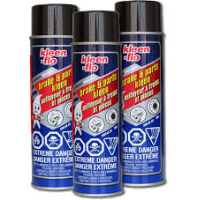
$2.40 EACH
CASE OF 12
WHILE SUPPIES LAST

CAMBRIAN TRUCK CENTRE
3433 KINGSWAY
SUDBURY ON
705-560-8736

